55 | 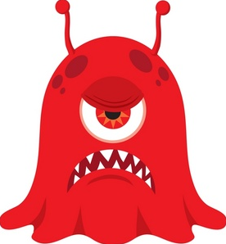 | I am not safe  I need to be removed from the situation before my actions or words hurt someone
4 | 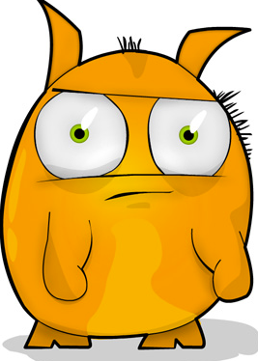 | I am losing control!!!!!  I need to use my relaxing techniques and some time alone to chill out and calm down
3 |  | I feel crazy and a little stressed, I need to take deep calming breaths and ask for further help
2 |  | I feel a little unsure but I am calm...I think I can do this
1 | 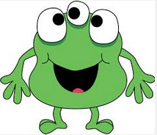 | I feel happy and confident

1
2
3
55
4
2
3
55
4
1
4
1
2
3
55

