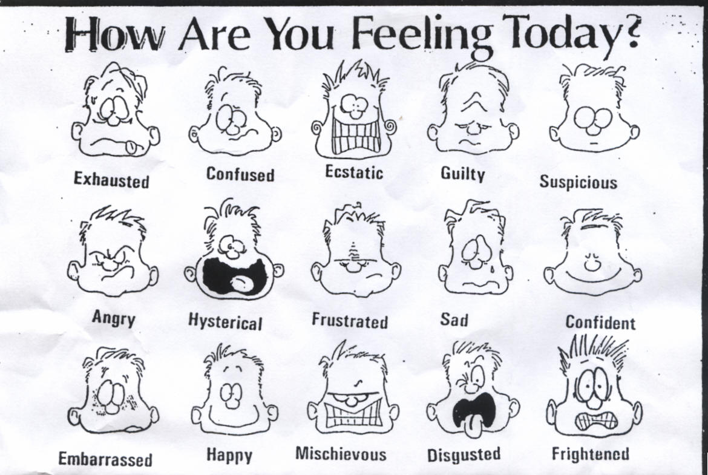
Colour the face/emotion that best
describes your day.
What happened to make you feel this way today?
________________________________________________________
________________________________________________________
________________________________________________________
________________________________________________________
________________________________________________________
________________________________________________________

Teachers comments: Parents comments:
________________________________________________________ ________________________________________________________
________________________________________________________ ________________________________________________________
________________________________________________________ ________________________________________________________

