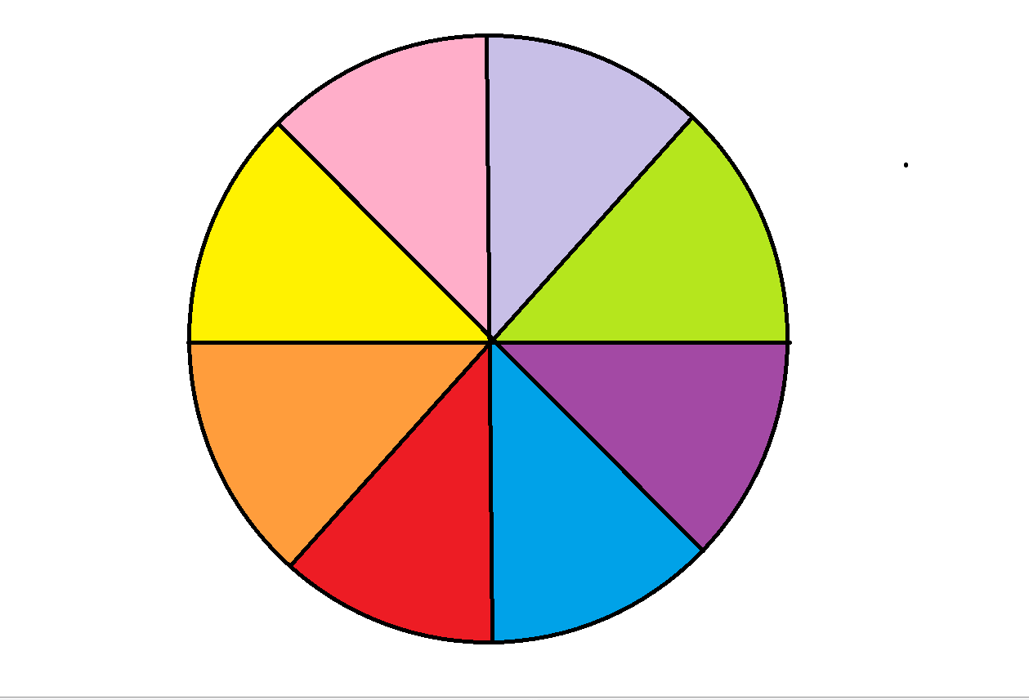

**Write a letter or story to express your feelings**

**Play with the activities in the chill out zones ‘emotion box’; play-doh, pick-up sticks, the glitter jar etc.**

**Draw or colour in a picture**

**Whole class 5 minute Yoga break**

**Take 10 deep breaths**

**Read a story from the chill out zone**

**Listen to one song in the chill out zone from the classroom I-pod**

**Chat to your listening buddy for 2 minutes in the chill out zone**



**Do your favourite thing with Mum or Dad; bake, play soccer etc.**

**Ring a friend to chat**

**Write a poem or story**

**Complete a ‘How I feel today star’ picture**

**Ride your bike or go for a walk with Mum or Dad**

**Have a sleep**

**Watch your favourite movie**

**Listen to music in your room**

